|  |  |
| --- | --- |
| Covid-19 pandemic and chaos theory: Why the future is impossible to  precisely predict - Vox  CHAOS PROGRAMS  User Guide | Written by Hayley Raj  Last edited by Austin Scholp on June 4th, 2021 |

Contents

Spectrum Convergence Ratio (SCR) 2

Rate of Divergence (ROD) 3

Jitter & Shimmer 4

TF32 4

MATLAB Script 4

Praat (Not on GitHub) 5

Moving Window and Concatenation 6

MATLAB Version 6

LabVIEW Version 6

D2 & K2 7

NEDR 8

## Spectrum Convergence Ratio (SCR)

Main File:

* *batchSCR.m*

Other Required Files:

* *getSCR.m*
* *time_freq_analysis.m*

Other Requirements:

* Can only analyze wave file (.wav extension).
* 0.75 second samples should be used for accurate results.

Instructions

1. Move all the wave files you want to analyze into a folder.
2. Open *batchSCR.m* with the most up-to-date version of MATLAB available on your computer.
3. Run the *batchSCR.m* script.
   1. If MATLAB displays a message about files not being in current folder, select change folder, **do not add to path**)
   2. If you do not see the Run button, make sure you have the Editor tab open.
4. Select the wave files of interest. Ctrl/shift to multi-select.
   1. You must select more than one file.
5. After files are selected, click ‘Open’.
6. The SCR results will show up in a .csv (Comma Separated Values – open with Excel) file in the Results folder.
   1. The results folder will be within the same folder where *batchSCR.m* is located.
   2. The file will be named SCR_Results_DD-Month-YYYY_HH-MM-SS

## Rate of Divergence (ROD)

Main Files:

* *batchMakeFragmentsForRODDialog.m*
* *playDOSBox.bat*

Instructions

Part 1

1. Move all the wave files you want to analyze into a folder.
2. Open *batchMakeFragmentsForRODDialog.m* with the most up-to-date version of MATLAB available on your computer.
3. Run the ‘batchMakeFragmentsForRODDialog.m’ script.
   1. If MATLAB displays a message about files not being in current folder, select change folder, **do not add to path**)
   2. If you do not see the Run button, make sure you have the Editor tab open.
4. Click ‘select Dir’ and a choose wave file from your folder of samples.
   1. You only need to pick one, they will not all highlight, but they will be loaded.
5. Click ‘Batch Make’ (single make does not work)
6. Folders with 8 fragments for each wave file will appear in your folder of samples.
7. Rename files so that the fragments corresponding to each wave file can be easily distinguished.

Part 2

1. Open the ‘CDA22’ folder.
   1. This should be found in the ROD Analysis folder, assuming you downloaded everything from GitHub.
2. Delete any .dat files that are still there or move them into different folder (if there are too many files, DOSBox may not work).
3. Copy fragments from Part 1 into the ‘CDA22’ folder.
   1. They cannot be in subfolders.
4. Open *playDOSBox*.*bat* (Make sure you are in DOSBox-0.74 folder)
   1. It says CHAOS.dat not found- just click okay.
5. Select fragment of interest (if not already at file list, click ‘T’)
6. Press ‘H’ to run (Lyapunov Exponent)
7. You can minimize screens if you want; make sure not to close any screens.
   1. ***press Ctrl-F10 to release cursor from the window as it will get trapped.***
8. You will need to open a new DOSBox window for each fragment that you run; if you need to you can run 30-40 fragments at one time, but if you run more your computer will slow down significantly.
9. Final ROD value for a specific .wav file:
   1. Make sure every fragment is 100% done running (when done, the % disappears)
   2. Take the average of the ROD values for the 8 fragments (the value given for the exponent; you do not need the margin of error)

## Jitter & Shimmer

### TF32

This program can be used to analyze voice samples for % jitter, % shimmer, SNR, and F0.

1. File > open > choose file.
2. If you want to choose a specific segment: click over the sample so that two white bars appear; the portion of interest should be between the bars.
3. View > open > Jitter > compute
4. If you are analyzing multiple files in one folder, you can just use the Next/Prev buttons in the main window to move between samples.

### MATLAB Script

Main File:

* *batch_JitterShimmer.m*

Other Required Files:

* *JitterShimmer.m*
* *Peakdet.m*

Instructions

1. Move all the wave files you want to analyze into a folder.
2. Open *batch_JitterShimmer.m* with the most up-to-date version of MATLAB available on your computer.
3. Run the *batch_JitterShimmer.m* script.
   1. If MATLAB displays a message about files not being in current folder, select change folder, **do not add to path**)
   2. If you do not see the Run button, make sure you have the Editor tab open.
4. Select the wave files of interest. Ctrl/shift to multi-select.
   1. You must select more than one file.
5. After files are selected, click ‘Open’.
6. The results will show up in a .csv (Comma Separated Values – open with Excel) file in the Results folder.
   1. The results folder will be within the same folder where *batch_JitterShimmer.m* is located.
   2. The file will be named JitterShimmer_Results_DD-Month-YYYY_HH-MM-SS

## Praat (Not on GitHub)

This program can be used for visualizing the spectrogram of a voice sample, which we often use for assigning a voice type. It can be downloaded from [here](https://www.fon.hum.uva.nl/praat/).

1. Copy voice samples of interest into one folder.
2. Open the Praat application and in the Praat Objects tab, click Open > Read from file.
3. Select a wave file from your folder of samples.
4. Click ‘Analyze spectrum’ > ‘To Spectrogram’.
5. 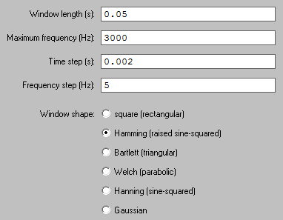Change default settings to:
6. Click ‘Ok’ > ‘View’.

## Moving Window and Concatenation

### MATLAB Version

Main File:

* *wavCapture.m*

Instructions

1. Right-click *wavCapture.m* and select ‘open with MATLAB R2013b’.
2. 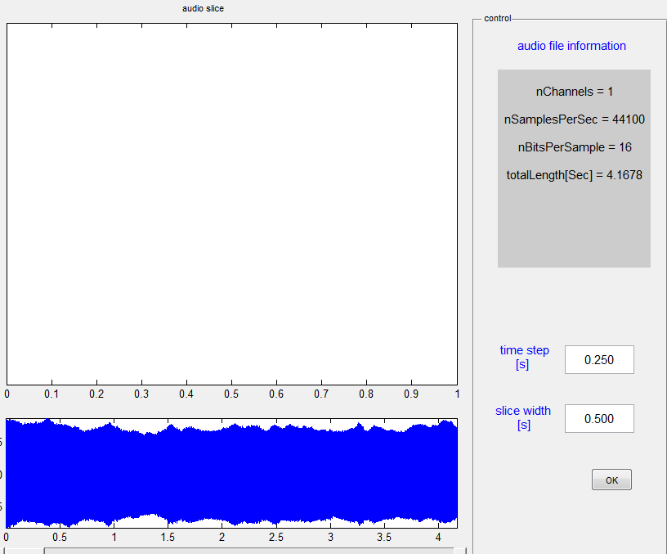Click ‘Run’ and the wavCapture window should open.
3. In the top left corner, there is a folder button where you can select your .wav file.
4. If you want to change and time step or slice width, you can do this in the bottom right corner.
5. Click OK > Save button (upper left corner) and the program should start slicing the sample.
6. A folder with all the fragments will appear in the same location as the original file.
7. Ranking the fragments
   1. If you are looking for the least perturbed fragment you can separately analyze each fragment and build a “stability score”. Look at “Moving window ranking example” on desktop of front computer (you can see formula in row 3).
   2. If you build a new spreadsheet with different parameters, make sure to be consistent with what should be considered the lowest rank for a given parameter (e.g., low NEDR is ranked low because it should increase as the voice becomes more disordered. High SCR is ranked low because the opposite trend from NEDR is observed).
   3. In the example spreadsheet, the lowest ‘Final Rank’ is the “least perturbed” fragment.

### LabVIEW Version

1. Open a version of the program, the installed version will be easiest.
   1. Only open the LabVIEW project if you know what you are doing.
2. Click the “Open” button.
3. Select a wav file.
4. Click the “Segment” button.
5. All done!

## D2 & K2

**DISCLAIMER:** The main script has not undergone thorough testing as of this writing. It is only loosely based on the original. Austin cobbled it together from parts of the 2011 version and some functions that are only in newer versions of MATLAB. The results for D2 seem reasonable but have not been compared against previous analysis. The K2 part of the script is unchanged from the original.

Main File:

* *D2K2.m*

Other Required Files:

* *ComputeSlope.m*
* *genKq.m*
* *randref.m*
* *genDimension.mexw64*
* *maxPCorr.mexw64*
* *minPCorr.mexw64*

Other MATLAB Requirements:

* Signal Processing Toolbox
* Statistics and Machine Learning Toolbox
* System Identification Toolbox
* Predictive Maintenance Toolbox

Instructions

1. Move all the wave files you want to analyze into a folder.
2. Open *D2K2.m* with the most up-to-date version of MATLAB available on your computer.
3. Run the *D2K2.m* script.
   1. If MATLAB displays a message about files not being in current folder, select change folder, **do not add to path**).
   2. If you do not see the Run button, make sure you have the Editor tab open.
4. Select a file to analyze.
5. A graph will appear eventually. When this happens, move the dotted lines to mark the beginning and end of the linear region of the plot.
6. Once set, enter the X-position of the left cursor in the command window. Do the same thing for the right cursor.
7. After both positions are entered, D2 will be calculated.
8. Calculation of K2, K∞, and K-∞ all follow a similar procedure, but with a worse user interface.
   1. Old instructions say to locate the beginning and end of the linear region of the plot furthest to the right.

## NEDR

Main File:

* *batchNEDR.m*

Other Required Files:

* *iterateNLSS.m*
* *NLSTFT.m*
* *polylsqr.m*
* *tftb_window.m*

Other Requirements:

* Can only analyze wave files (.wav extension).
* 0.75 second samples should be used for accurate results.
* Uses the Signal Processing Toolbox
* Uses the Curve Fitting Toolbox

Instructions

1. Move all the wave files you want to analyze into a folder.
2. Open *batchNEDR.m* with the most up-to-date version of MATLAB available on your computer.
3. Run the *batchNEDR.m* script.
   1. If MATLAB displays a message about files not being in current folder, select change folder, **do not add to path**)
   2. If you do not see the Run button, make sure you have the Editor tab open.
4. Select the wave files of interest. Ctrl/shift to multi-select.
   1. You must select more than one file.
5. After files are selected, click ‘Open’.
6. The results will show up in a .csv (Comma Separated Values – open with Excel) file in the Results folder.
   1. The results folder will be within the same folder where *batchNEDR.m* is located.
   2. The file will be named NEDR_Results_DD-Month-YYYY_HH-MM-SS